Hardcoding Test Names so they are displayed even when the test result is empty

Copy the file ACL Extractor V5_2007.xlsm to <ClientName> ACL Extractor V5_2007.xlsm

Open <ClientName> ACL Extractor V5_2007.xlsm

Click Developer Tab

Click Visual Basic

Ctrl-F

Do a search in “Current Project” for Range("C3").Font.Bold = True

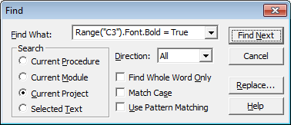

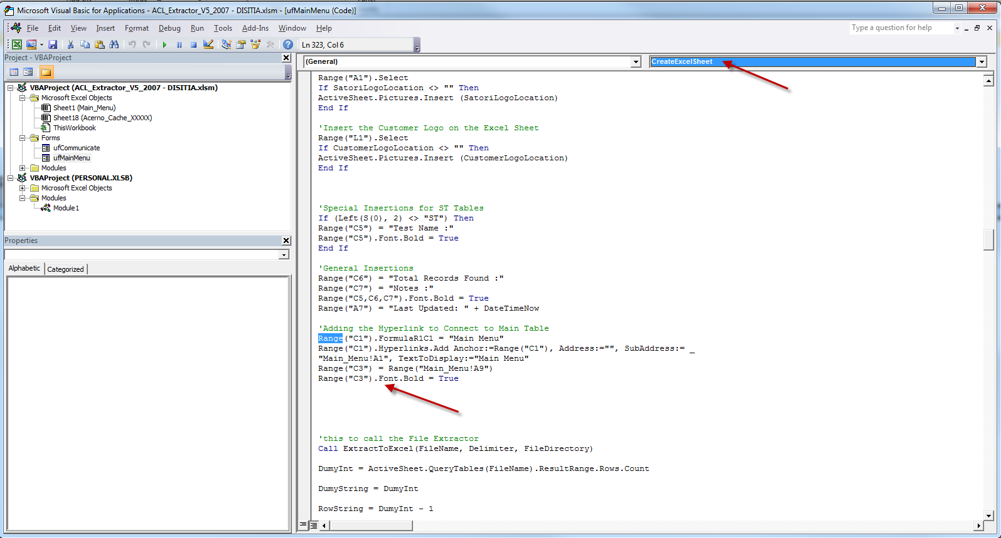

Then below this section

|  |
| --- |
| 'Adding the Hyperlink to Connect to Main Table  Range("C1").FormulaR1C1 = "Main Menu"  Range("C1").Hyperlinks.Add Anchor:=Range("C1"), Address:="", SubAddress:= _  "Main_Menu!A1", TextToDisplay:="Main Menu"  Range("C3") = Range("Main_Menu!A9")  Range("C3").Font.Bold = True |

Add the new code below but you must adjust it depending on which tests your client has.

|  |
| --- |
| ' The value will be replaced later if there are results found  Sheets(S(0)).Range("E6") = "No Results Found"  ' Hardcoding the test names so that the test name is displayed even if there are no test results (0 rows).  ' Must be customized for the particular customer. The list below is for Melbourne University.  If S(0) = "AP001" Then  Sheets(S(0)).Range("E5") = "AP001. Duplicated Invoices by InvNo,Amt,Date and VndNbr"  ElseIf S(0) = "AP002" Then  Sheets(S(0)).Range("E5") = "AP002. Duplicated Invoices by InvNo,Amt and VndNbr (Diff Date)"  ElseIf S(0) = "AP003" Then  Sheets(S(0)).Range("E5") = "AP003. Duplicated Invoices by InvNo,Amt and Date (Diff VndNbr)"  ElseIf S(0) = "AP004" Then  Sheets(S(0)).Range("E5") = "AP004. Duplicated Invoices by Vendor,Amt and Date (Diff Invoice Number)"  ElseIf S(0) = "AP005D" Then  Sheets(S(0)).Range("E5") = "AP005D.Identify vendors with more than 3 consecutive invoice numbers - Details"  ElseIf S(0) = "AP005" Then  Sheets(S(0)).Range("E5") = "AP005.Identify vendors with more than 3 consecutive invoice numbers - Summary"  ElseIf S(0) = "AP006" Then  Sheets(S(0)).Range("E5") = "AP006.Identify payments made to vendors not in vendor master file"  ElseIf S(0) = "AP017D" Then  Sheets(S(0)).Range("E5") = "AP017D. Top/Bottom x Vendors over x months - Details"  ElseIf S(0) = "AP017" Then  Sheets(S(0)).Range("E5") = "AP017. Top/Bottom x Vendors over x months"  ElseIf S(0) = "AP019" Then  Sheets(S(0)).Range("E5") = "AP019. Identify Invoices where a credit note exists yet Payment has been made"  ElseIf S(0) = "AP020D" Then  Sheets(S(0)).Range("E5") = "AP020D. Identify Vendors with total number of monthly payments > x - Details"  ElseIf S(0) = "AP020" Then  Sheets(S(0)).Range("E5") = "AP020. Identify Vendors with total number of monthly payments > x"  ElseIf S(0) = "VM001" Then  Sheets(S(0)).Range("E5") = "VM001. Identify Duplicate Vendors by Bank Account"  ElseIf S(0) = "VM002" Then  Sheets(S(0)).Range("E5") = "VM002. Identify Duplicate Vendors by Vendor ABN Number"  ElseIf S(0) = "VM003" Then  Sheets(S(0)).Range("E5") = "VM003. Identify Duplicate Vendors by Address"  ElseIf S(0) = "VM004" Then  Sheets(S(0)).Range("E5") = "VM004. Identify Duplicate Vendors by Telephone No/Mobile Number/Fax"  ElseIf S(0) = "VM005" Then  Sheets(S(0)).Range("E5") = "VM005. Identify Duplicate Vendors by Vendor Name"  ElseIf S(0) = "VM007D" Then  Sheets(S(0)).Range("E5") = "VM007D. Identify transactions against vendors with Incorrect ABN Format"  ElseIf S(0) = "VM007" Then  Sheets(S(0)).Range("E5") = "VM007. Identify Vendor with Incorrect ABN Format"  ElseIf S(0) = "VM008D" Then  Sheets(S(0)).Range("E5") = "VM008D. Identify Transactions with Inv_Dt >Cancelled ABN Effective Date"  ElseIf S(0) = "VM008" Then  Sheets(S(0)).Range("E5") = "VM008. Identify Deregistered/Cancelled ABN"  ElseIf S(0) = "VM009D" Then  Sheets(S(0)).Range("E5") = "VM009D. Identify Transactions against Vendors with Valid ABN but not on ABR site (not found)"  ElseIf S(0) = "VM009" Then  Sheets(S(0)).Range("E5") = "VM009. Identify Valid ABN but not on ABR site (not found)"  ElseIf S(0) = "VM010D" Then  Sheets(S(0)).Range("E5") = "VM010D. Identify transactions by vendors not registered for GST or Inv_Dt >GST expired Date"  ElseIf S(0) = "VM010" Then  Sheets(S(0)).Range("E5") = "VM010. Identify vendors not registered for GST"  ElseIf S(0) = "VM014A" Then  Sheets(S(0)).Range("E5") = "VM014A. Vendor details matching employee details on Bank Account (excluding Student Vendors with matching surnames with Employee)"  ElseIf S(0) = "VM014" Then  Sheets(S(0)).Range("E5") = "VM014. Vendor details matching employee details on Bank Account"  ElseIf S(0) = "VM015A" Then  Sheets(S(0)).Range("E5") = "VM015A. Vendor details matching employee details by Address (excluding Student Vendors with matching surnames with Employee)"  ElseIf S(0) = "VM015" Then  Sheets(S(0)).Range("E5") = "VM015. Vendor details matching employee details by Address"  ElseIf S(0) = "VM016A" Then  Sheets(S(0)).Range("E5") = "VM016A. Vendor details matching employee details on Telephone No/Mobile/Next of Kin Number (excluding Student Vendors with matching surnames with Employee)"  ElseIf S(0) = "VM016" Then  Sheets(S(0)).Range("E5") = "VM016. Vendor details matching employee details on Telephone No/Mobile/Next of Kin Number"  ElseIf S(0) = "VM017" Then  Sheets(S(0)).Range("E5") = "VM017. Identify Duplicate Vendors by Email"  ElseIf S(0) = "EM001" Then  Sheets(S(0)).Range("E5") = "EM001. Identify duplicate employees: By TFN."  ElseIf S(0) = "EM001A" Then  Sheets(S(0)).Range("E5") = "EM001A. Identify duplicate employees: By TFN. (All TFN and both CERA and non-CERA employees)"  ElseIf S(0) = "EM002A" Then  Sheets(S(0)).Range("E5") = "EM002A. Identify duplicate employees: By Bank Account (excluding probable spouses)"  ElseIf S(0) = "EM002" Then  Sheets(S(0)).Range("E5") = "EM002. Identify duplicate employees: By Bank Account."  ElseIf S(0) = "EM003" Then  Sheets(S(0)).Range("E5") = "EM003. Identify duplicate employees: By Name"  ElseIf S(0) = "EM004A" Then  Sheets(S(0)).Range("E5") = "EM004A. Identify duplicate employees: by Address (and same Name or DOB)"  ElseIf S(0) = "EM004" Then  Sheets(S(0)).Range("E5") = "EM004. Identify duplicate employees: by Address"  ElseIf S(0) = "EM005A" Then  Sheets(S(0)).Range("E5") = "EM005A. Identify duplicate employees: By Telephone(s) (and same Name or DOB)"  ElseIf S(0) = "EM005" Then  Sheets(S(0)).Range("E5") = "EM005. Identify duplicate employees: By Telephone(s)"  ElseIf S(0) = "EM006" Then  Sheets(S(0)).Range("E5") = "EM006. Identify Employees with missing details"  ElseIf S(0) = "EM007" Then  Sheets(S(0)).Range("E5") = "EM007. Identify employees with start date before their date of birth"  ElseIf S(0) = "EM009" Then  Sheets(S(0)).Range("E5") = "EM009. Identify Employees with Tax File No that does NOT confirm with ATO algorithm"  ElseIf S(0) = "EM010" Then  Sheets(S(0)).Range("E5") = "EM010. Tax File No. validation: Blank TFN"  ElseIf S(0) = "EM011" Then  Sheets(S(0)).Range("E5") = "EM011. Employee bank account details have been changed more than 1 time(s) in 3 months"  ElseIf S(0) = "EM012" Then  Sheets(S(0)).Range("E5") = "EM012. Date of birth and age validation: Blank date of birth, employee >65 years or employee < 16 years"  ElseIf S(0) = "EM013" Then  Sheets(S(0)).Range("E5") = "EM013. Start date validation: Find employment days < 30 days or employment days > 15,000 days"  ElseIf S(0) = "EM014" Then  Sheets(S(0)).Range("E5") = "EM014. Employees in temporary position without end date"  ElseIf S(0) = "PR002BD" Then  Sheets(S(0)).Range("E5") = "PR002BD. Identify payments made to employees not in master file or payments made after contract end/termination date"  ElseIf S(0) = "PR002B" Then  Sheets(S(0)).Range("E5") = "PR002B. Identify and summarise payments made to employees not in master file or payments made after contract end/termination date"  ElseIf S(0) = "PR002D" Then  Sheets(S(0)).Range("E5") = "PR002D. Identify payments made to employees not in master file"  ElseIf S(0) = "PR002" Then  Sheets(S(0)).Range("E5") = "PR002. Identify and summarise payments made to employees not in master file"  ElseIf S(0) = "PR003" Then  Sheets(S(0)).Range("E5") = "PR003.Identify payments to employees %TXT_PR003_Days% days after termination date"  ElseIf S(0) = "PR005D" Then  Sheets(S(0)).Range("E5") = "PR005D. Identify sleeper employees who have been paid termination amount - Details"  ElseIf S(0) = "PR005" Then  Sheets(S(0)).Range("E5") = "PR005. Identify sleeper employees who have been paid termination amount"  ElseIf S(0) = "PR007D" Then  Sheets(S(0)).Range("E5") = "PR007D. List all hourly employees working > the total hours available in week between x date and x date - Details"  ElseIf S(0) = "PR007" Then  Sheets(S(0)).Range("E5") = "PR007. List all hourly employees working > the total hours available in week between x date and x date"  ElseIf S(0) = "PR008A" Then  Sheets(S(0)).Range("E5") = "PR008A. Top 20 fortnightly employees between x date AND x date"  ElseIf S(0) = "PR008B" Then  Sheets(S(0)).Range("E5") = "PR008B. Top 20 casual employees between x date AND x date"  ElseIf S(0) = "PR008D" Then  Sheets(S(0)).Range("E5") = "PR008D. Top 20 employees between x date and x date - Details"  ElseIf S(0) = "PR009A" Then  Sheets(S(0)).Range("E5") = "PR009A. Identify Fortnightly Employee with Current Period Payment (Gross Pay) is different from Previous Period Payment by +/- x % within 13 months"  ElseIf S(0) = "PR009B" Then  Sheets(S(0)).Range("E5") = "PR009B. Identify Casual Employee with Current Period Payment (Gross Pay) is different from Previous Period Payment by +/- x % within 13 months"  ElseIf S(0) = "PR013" Then  Sheets(S(0)).Range("E5") = "PR013. Identify Active Employees without Payslip (not on payrun)"  End If |

Then click Save.